Daily Progress: Day 1

Daily Class Goals:

* Introduce Instructor and Students
* Discuss the history and future of computers
* Cover the basics of computer hardware
* Cover chapter 1 & 2 of the textbook

Activities

* Discuss computing devices
* Identify internal computer components
* Connector types
* Identify peripheral devices
* Comparing functions and features of operating systems
* Identifying application software

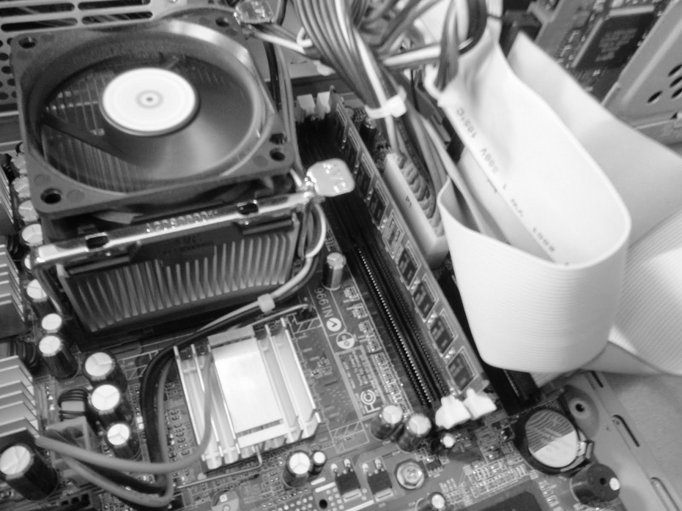

Daily Progress: Day 2

Daily Class Goals:

* Build a computer

Activities

* Building half of the class computers

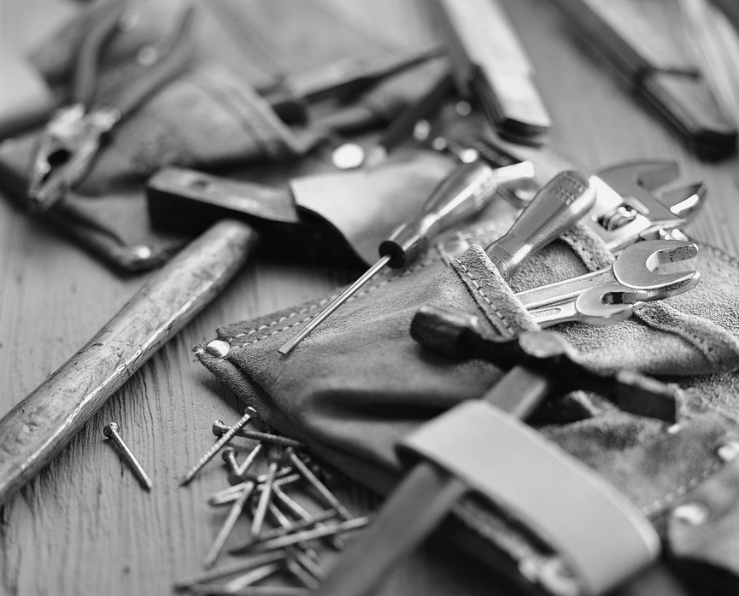

Daily Progress: Day 3

Daily Class Goals:

* Build a computer
* Begin chapter 3 of the textbook

Activities

* Building the remaining class computers
* Troubleshooting all computers

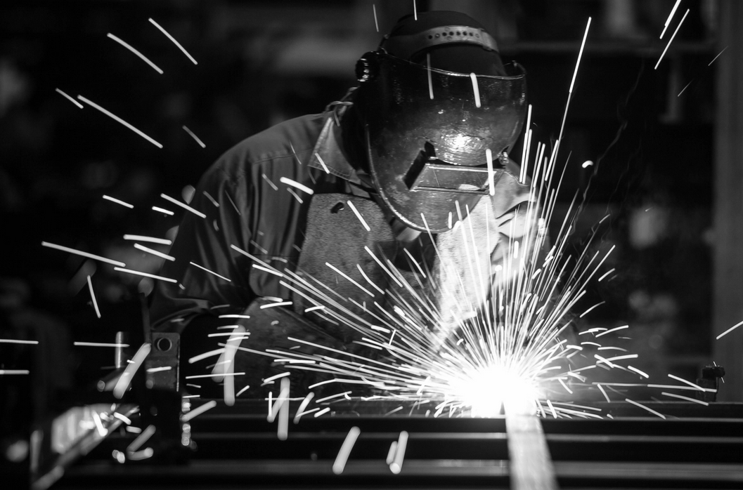

Daily Progress: Day 4

Daily Class Goals:

* Continue troubleshooting
* Complete OS installation
* Cover chapter 3 of the textbook

Activities

* Install and configure OS
* Discuss chapter 3



Daily Progress: Day 5

Daily Class Goals:

* Discuss networks and network hardware
* Cover chapter 4 of the textbook

Activities

* Comparing Network Connection Types
* Installing and Configuring a Router
* Identifying Network and Alternative Technologies
* Comparing Methods for Sharing and Storing Information

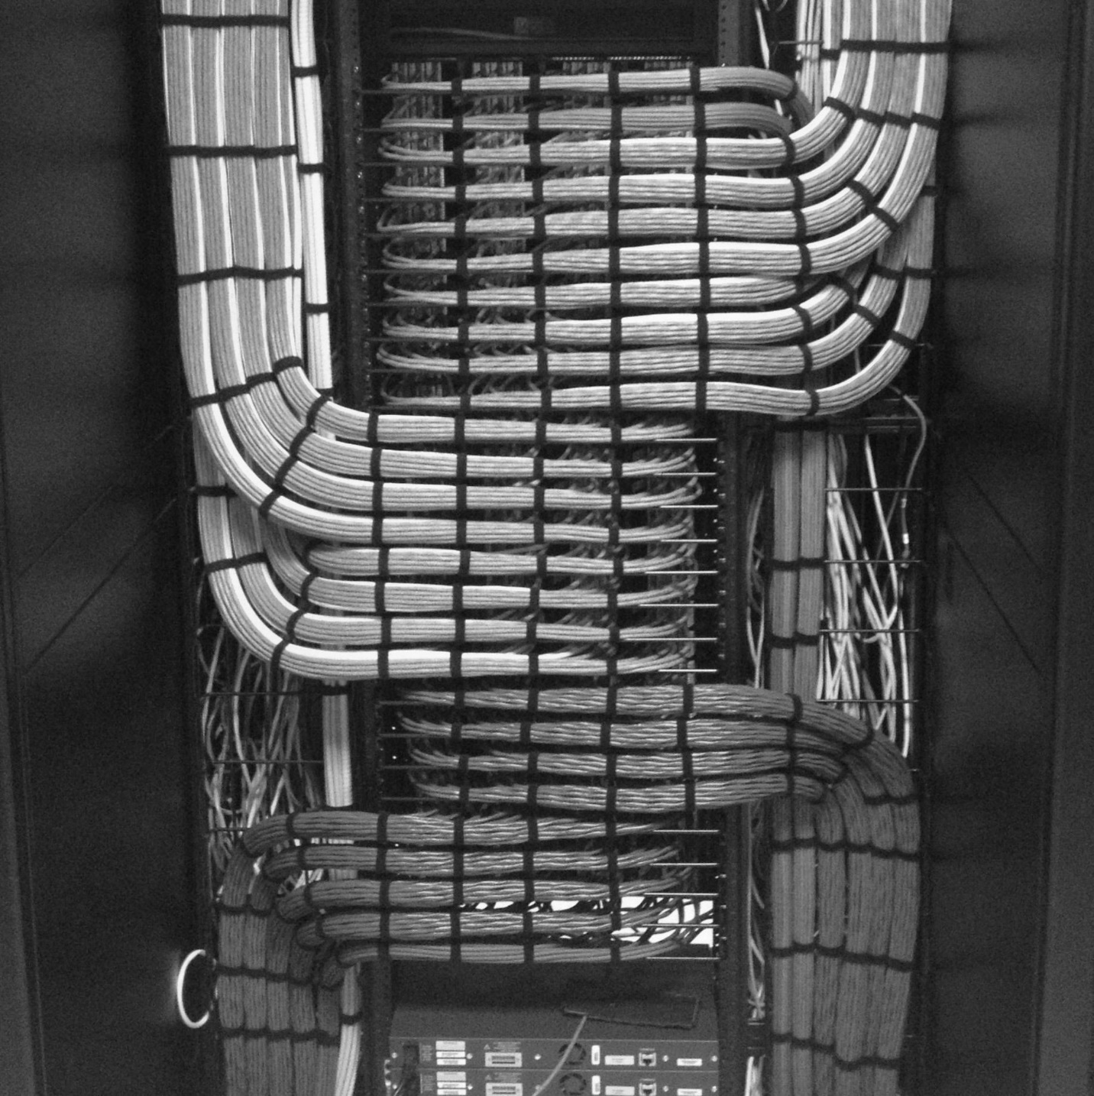

Daily Progress: Day 6

Daily Class Goals:

* Discuss files and the explorer, compression, and wireless devices
* Cover chapter 5 & 6 of the textbook

Activities

* Creating Files
* Navigating a File Structure with File Explorer
* Managing Files and Folders
* Using the Recycle Bin
* Compressing and Extracting Files
* Creating Screen Captures
* GIMP and image types

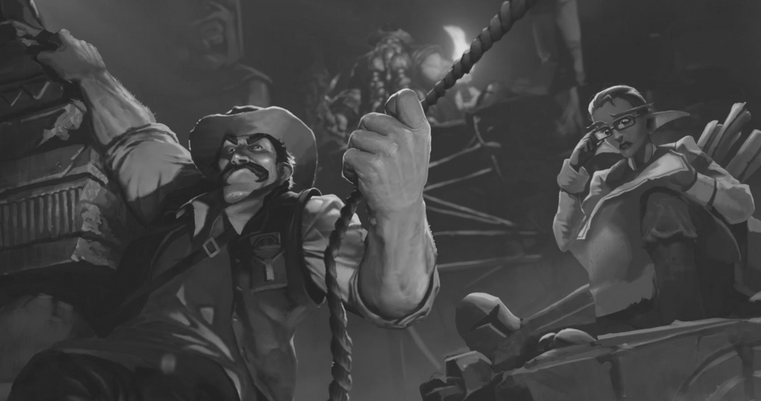

Daily Progress: Day 7

Daily Class Goals:

* Discuss securing computing devices and supporting computers and users
* Cover chapter 7 & 8 of the textbook

Activities

* Identifying Security Threats
* Applying Security Best Practices
* Securely Browsing the Web
* Discussing Environmental and Safety Concepts
* Backing Up Data
* Restoring Data from Backup
* Managing Software Updates
* Implementing Basic Support Measures

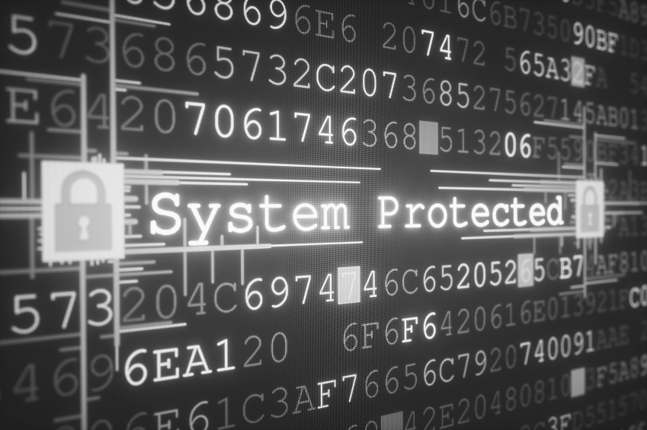

Daily Progress: Day 8

Daily Class Goals:

* Review IT Fundamentals information
* Take IT Fundamentals Certification

Activities

* Review for Exam
* Take Exam

